Writing Guide

Reading Philosophy
Philosophical works of writing come in two general forms: novel and article. Philosophy textbooks are either summaries of both or collections of articles.
When reading a philosophical novel, such as The Meditations by Marcus Aurelius or The Seducer’s Diary by Soren Kierkegaard, the first thing to do is just to read it like you would a normal recreational novel. This allows you to appreciate the writing style of the author. If the novel was boring or difficult to understand, then the author has trouble conveying their ideas across. This means that their ideas are either very complicated and difficult to communicate, or that the author has insufficient writing skills to explain their ideas.
Having read the novel as a piece of literature, the next thing to do is to read the novel as a piece of philosophy. Seek out the sections of the story that seem to comment on daily life. For example, in Aurelius’ novel, every section is a commentary on his life and lessons that he’s learned, so you must dig through the treasure trove of gold to find the silver, so to speak. His novel is very repetitive, so the parts that are new and original, or particularly inspiring, are the true philosophical coins. For Kierkegaard’s novel, on the other hand, the story is riveting and brilliantly fictional, but the philosophical content is hidden behind the narrative. To find it, you must look between the lines to see what Kierkegaard’s point was in writing it and how that connects to his philosophical ideas about existentialism and the aesthetic life.
All philosophical novels, such as Plato’s Dialogues, are somehow connected to their philosophical ideas. Usually, you will study those ideas before reading the novel. This greatly aids in understanding the hidden meanings. If you read Kierkegaard’s The Seducer’s Diary before studying his philosophical ideas, you might think that he was a psychopath encouraging people to deceive young women to steal their innocence. However, if you read his novel after studying his aesthetic and existential breakdowns, you will see that he is writing to show how evil that lifestyle is and how pointless it is. This turns the novel into a perfect example of something that he describes theoretically and demonstrates the practical application of his concepts.
Conversely, when reading philosophical articles, ideas are laid out in an organized and clear fashion – in theory, at least. Just like authors for novels, some philosophers are simply inadequate writers and have great difficulty in explaining their ideas. Again, sometimes that’s because the ideas themselves are hard to convey, but other times, the writers just don’t have the skills required. Most contemporary philosophical articles are very well-written and clear. This is because of a change in teaching requirements that put an emphasis on writing skills, as well as a change in editing direction. Editors of philosophical magazines and journals no longer print articles as they were originally written. They require that the writing be clear and concise to keep up their standards, so philosophers are being forced to develop their writing skills more now than before.
When you are reading a philosophical article, the first thing to do is actually not to read through it completely. You can tell a lot about the philosopher’s organization by skimming. Read the first sentence of every paragraph. That should give you a clear outline of the article. If that doesn’t work, read the last sentence of every paragraph. If that still doesn’t work, the paper is unorganized and you will have to dig the outline out as you read. Next, use the outline (if you have one) to determine the argument being presented. What is the philosopher trying to say? What new idea are they presenting?
After that, read the full article from start to finish. With the outline and argument format in hand, reading the article should be easy. Read every sentence and every line, filling out your outline and argument to form a summary. It is good practice to write summaries of every article that you read. There are not very many philosophical articles in existence when you compare the number of articles in this field to other fields like physics, literature, or history. The bulk of philosophical articles have been written in the last fifty years. As such, you will likely have to read the same article again later on in a different class, so a summary helps reduce the amount of reading that you will have to do in total.
Finally, using only your summary, attempt to explain to someone else, or to yourself, what it is that you just read. If you can’t, then you didn’t really understand it. The mark of true understanding of material is the ability to teach it to someone else. If you can’t do that, then you didn’t fully comprehend it and you need to start the process all over again.

Writing in general
In general, college requires students to turn out about two papers per class for the first through third year, and four papers per class for the senior year. Then in graduate school, you will write a paper a week per class. As such, students must develop their writing skills early on and cultivate those skills as they go. The first step to that is understanding writing styles.
There are three major formatting styles used by academic fields: MLA, APA, and Chicago. MLA is simple and common in community colleges. APA is formal and common for universities or scientific fields. Chicago is rare, but similar to APA. The difference between them is all in the formatting of the template and the citation formatting. All three styles require 1-inch margins all around the paper, Times New Roman 12-point font, and double spacing between lines with no added spacing between paragraphs (that is a default setting in Microsoft Word that you will need to disable when you start off your paper).
MLA starts off with a four-line header. This is placed at the top of the paper in the left-hand corner of the first page. It includes the student name, professor name, course ID, and date that the paper is turned in (usually the due date). The page number is written in the header (the actual page header, which occurs in the margins and turns gray automatically after you finish editing it) proceeded by the student’s surname. Following the header is an intentional blank line, then a centered title of the paper. All paragraphs of the paper start with a 0.5-inch indentation. Here is an example of an MLA first page so that you can see what it looks like:
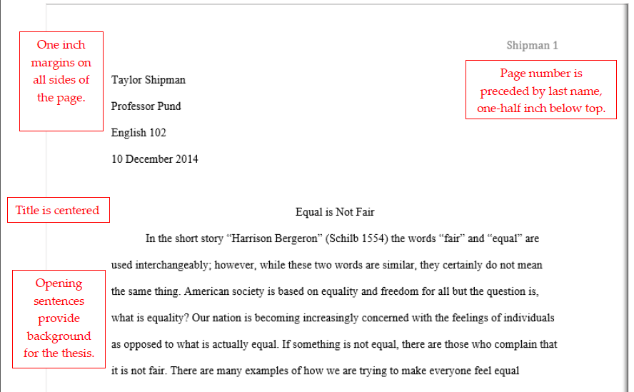
APA starts off with a title page. In the page heading, place a shortened title in the left-hand corner along with the page number. In the middle of the page, write the title of the paper followed by the student’s name, and at the bottom of the page, write the course title followed by the professor’s name. The second page is typically an abstract, which is a kind of summary of your paper. It is a formal requirement, but it is not uncommon for this to be left out of shorter papers such as the typical 2-5 page papers seen in community college and undergraduate courses. Here is an example of an APA paper:

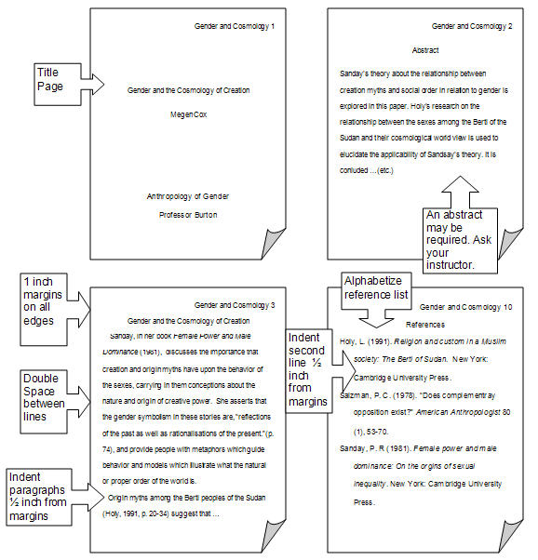
Works Cited or Reference pages are required on all formal papers. Parenthetical citations are not the same as a bibliography. A bibliography/works cited/reference page is required. Parenthetical citations are references to that page. They are meaningless without the bibliography, as are footnotes. If your paper does not have a bibliography, it is plagiarism!!!
Bibliographies are, at their cores, lists of the references that you used in your paper. References are to be reliable sources. Reliable sources are sources that come from academic or authoritative institutions, such as the Smithsonian Institute, universities, or academic journals. Published books, peer-reviewed academic journals, and reliable newspapers are all acceptable and reliable printed and e-book sources. Anything that comes from your school academic library is reliable. Internet sources must be sponsored by universities or governments to qualify as reliable, so .edu and .gov websites (and their international counterparts like .ac.uk) are reliable while .com and .org websites (and their international counterparts like .uk and .fr) are questionable. Not all encyclopedia’s are reliable. Some like Wikipedia are not peer-reviewed.

Every citation on a bibliography has a specific format that it is supposed to use for each formatting style. This makes up the bulk of formatting guides. For detailed formatting guides, try Purdue University’s OWL guide:
- For MLA: https://owl.english.purdue.edu/owl/section/2/11/
- For APA: https://owl.english.purdue.edu/owl/section/2/10/
- For Chicago: https://owl.english.purdue.edu/owl/section/2/12/
This is what a bibliography should look like:
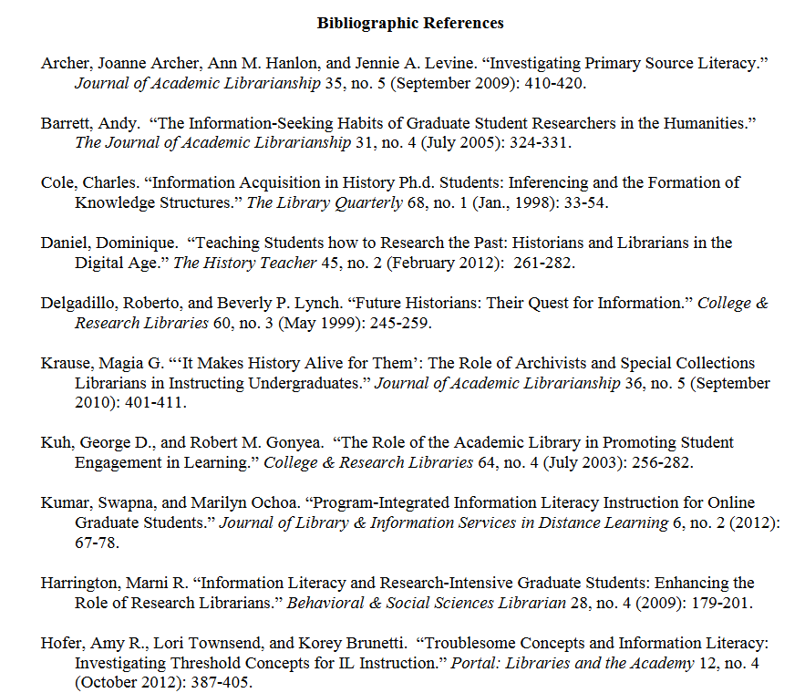
Entries are alphabetically ordered and start with the author’s name, then the source information. The order of information and what information is required is different for each kind of source. Book citations look different from article citations, which look different from film citations, which look different from lecture note citations. For specifics on each, refer to your formatting style’s formatting guide (links above).

Writing Philosophy
Philosophy papers are different from papers in every other field for a few reasons. Firstly, philosophy professors don’t care about flowery introductions and conclusions. We care about the bulk and meat of your paper. Do not waste our time with a half-page introduction. A really good philosophy paper is succinct and gets to the point immediately. Just slap your thesis in the first sentence and move on to proving your point. Every other first (not good) philosophy paper looks like this:
Plato was the greatest philosopher of all time. He created the field of philosophy and is responsible for its success even today. His idea of the Theory of Recollection was very interesting and helped build all philosophical theories that followed. It is a complex idea that inspired great things in the times to come.
Plato is dead. He doesn’t care if you flatter him, so don’t bother. The thesis of the above paper is that Plato’s theory of recollection was a foundational theory that shaped the course of epistemology, but you wouldn’t know it from that introduction, which makes it a waste of time. Instead, the paper should read more like this:
Plato’s theory of recollection shaped the field of epistemology by establishing an origin of knowledge, explaining the link between a priori and a posteriori knowledge, and connecting Plato’s theory of forms with his political experiment of the Republic.
That is to-the-point, succinct, and very clear. From that single sentence, the professor knows the thesis and supporting points, and there’s no needless flattery and flowery language.
Secondly, if any sentence in your paper does not serve a purpose, get rid of it. Everything in a philosophy paper must help explain your point. If you are just fluffing up your paper for length, your professor will know and will dock you for it. It is unprofessional and insulting to the professor to turn in fluff because it is a way to say ‘I don’t expect for you to be smart enough to see that I am fluffing up this paper or understand why I’m doing it.’ If you don’t have enough to say on your topic, either take a risk and turn it in short but well-written, or find more real purposeful content to add.
Thirdly, philosophy papers should be as well-organized as professional articles. As such, the main idea of each paragraph should be in either the first or last sentence of every paragraph and the rest of the paragraph should follow up on that point and explain it farther. The introduction is to explain the thesis and the supporting points to the thesis. The conclusion (if there is one, because sometimes you just don’t need it) restates the introduction and explains what the paper has achieved. If you think that you were clear enough in the introduction and paper, you don’t need a conclusion, especially for a short paper such as 1-3 pages. You also don’t always need transitional sentences. Sometimes, clearly changing points is better.
Finally, philosophy papers are completely allowed to have first person in them. I know that you have been taught never to use the words “I” or “me” in a formal paper. Break that tradition for philosophy. If you are writing what you think, you need to make sure that your reader knows that those are your thoughts. Do not skirt around it by saying “it is possible that this theory has a fatal flaw in it”. Just outright say “I suspect that this theory suffers from a fatal flaw”. Of course, only do this for your own ideas or examples from your own life. Don’t be afraid to personalize your paper with personal stories that prove your point, and never fear telling your reader what you really think. Philosophy is all about thinking, including your own thoughts. As long as it is appropriate for the paper, go for it.

Final Notes
Writing papers in college can be tedious, but practice makes perfect. If you blow it off, it will be harder to do it.
Some students are first-draft writers. They can whip out a really good paper without need of an outline or rough draft. However, some students aren’t. It is recommended that you use outlines and rough drafts until you can turn out a really good paper, then start reducing your preparation steps until you become a first-draft writer.
Always proof-read your paper. Nothing says ‘unprepared last-minute effort’ and ‘procrastination’ quite like a paper littered with errors. It really helps to read your paper aloud. That catches most common errors.
Don’t try to cheat the length requirement. We know. We notice. You aren’t getting away with anything. Reducing margins, making spacing bigger, adding pictures, adding fluff – what that tells a professor is that you are lazy. Don’t make that kind of impression. Just do the assignment properly. If you are short, find more real content to include.
Don’t be afraid to ask for help. We all need it sometimes.

